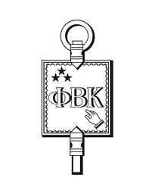

Phi Beta Kappa Association of Metropolitan Phoenix
October 24,2012
Annual Meeting Minutes

The annual dinner meeting of the Phi Beta Kappa Association membership was
held on October 24, 2012 at the Bluewater Grill, 1720 East Camelback Road,
Phoenix. The membership gathered at 6:00 p.m. for registration, silent
auction bidding and drinks.

Co-Presidents Elena Zee and Maire Simington welcomed the members. The
members enjoyed the ice-breaker emceed by Vice President Ann-Marie Anderson
about famous and infamous PBK inductees. Dinner and a short business
meeting ran from 6:45 p.m. to 8:00 p.m. The following officers were elected
by voice vote for the 2012-2013 year: Elena Zee and Maire Simington/
Co-Presidents, Ann-Marie Anderson/ Vice-President and Gail
Boyd/Treasurer/Recording Secretary.

The Treasurer, Gail Boyd, presented the financial report for the year. The
balance brought forward into 2012-2013 was $4,681.42. Income for 2011-2012
was $5,857.40 and expenses were $7,880.60. $5,000 was expended on
scholarships.

Bill Facinelli, Scholarship Chairman, introduced the ASU Scholarship
recipients Kavian Toosi and Faith Makris, who were invited by the Board to
attend the annual dinner.

Maire Simington, Co-President, introduced the speaker for the evening, Mary
Jo West, while dessert and coffee were served. Mary Jo's talk and
interaction with members was inspirational.

Silent auction winners were announced by Ellyn Stein. The silent auction
brought in $460 for the Association scholarships. The meeting was adjourned
around 9:00 p.m.

Respectfully Submitted,

Gail Boyd, Acting Recording Secretary

